1. Create a VM and install docker and test the images inside the container with the commands

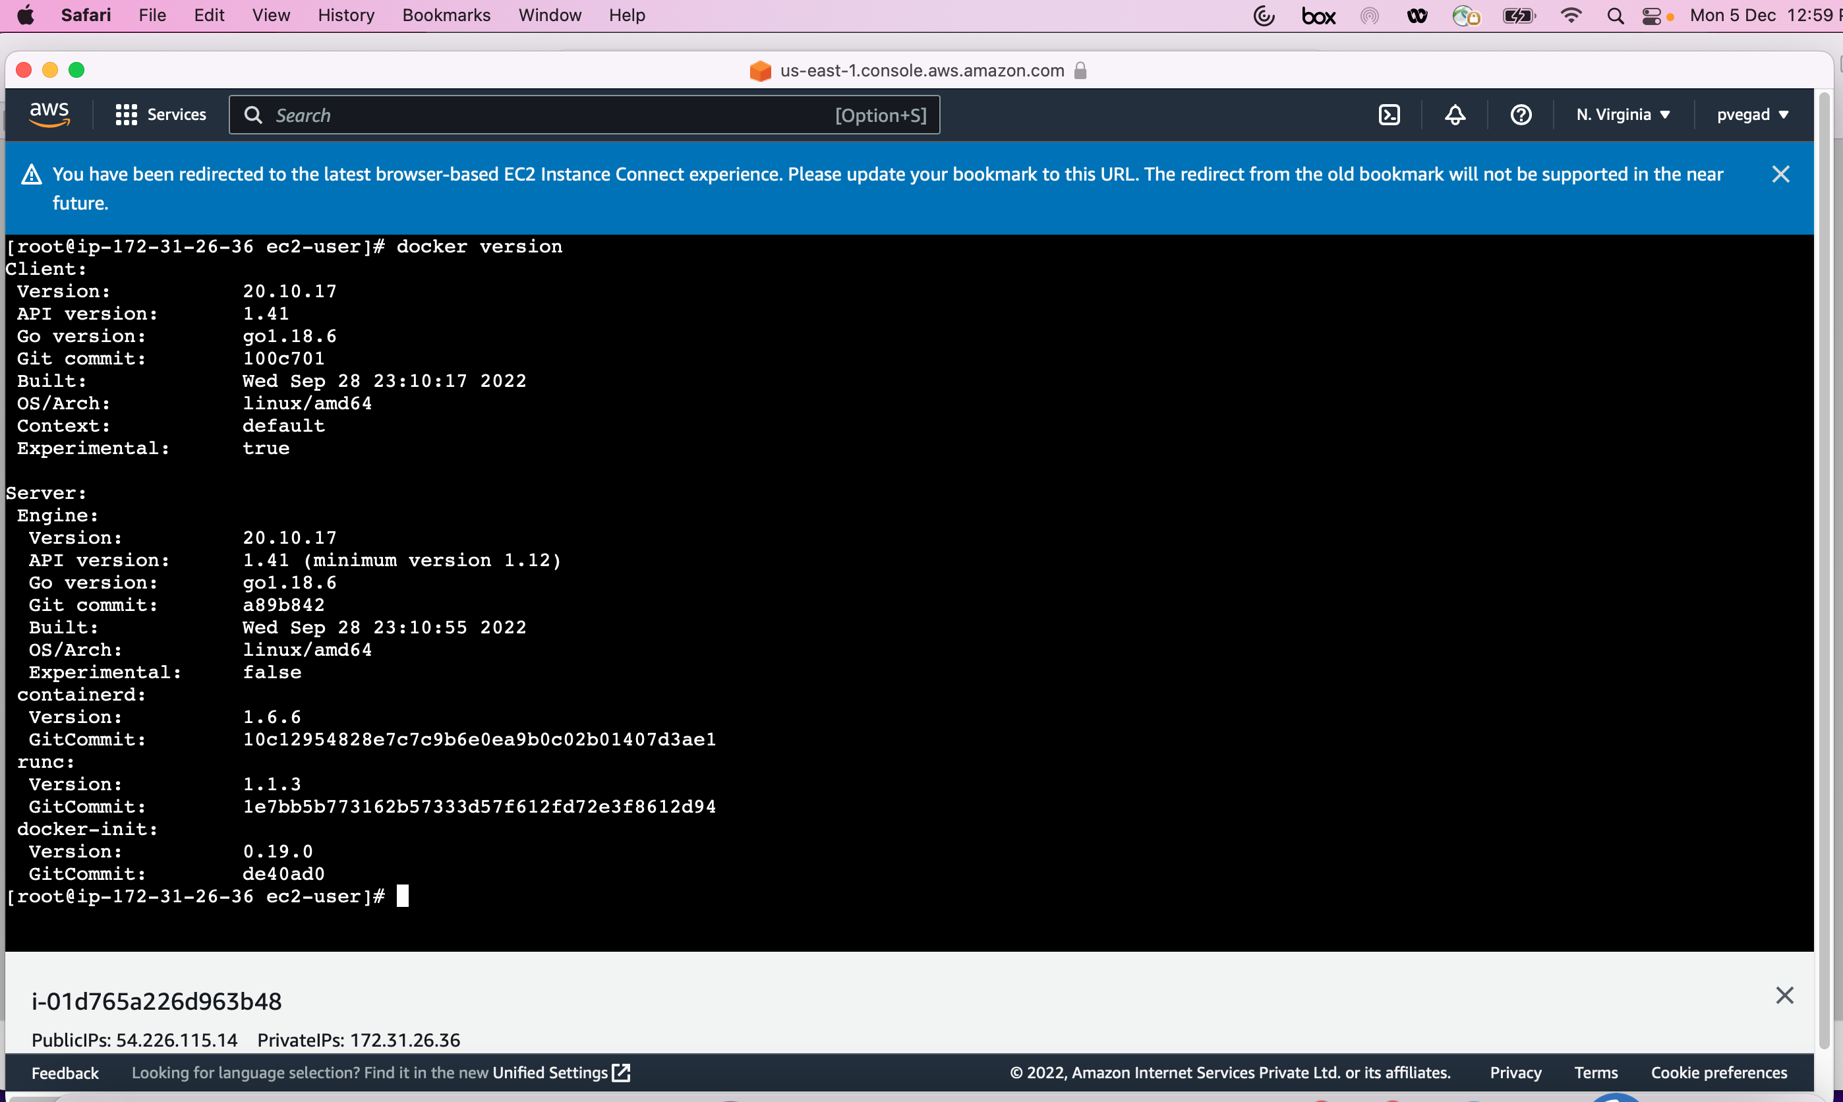

3. Launch minikube cluster and execute the commands to test the pod, container with the kubectl commands

$ kubectl create deployment pvassignment-node --image=registry.k8s.io/e2e-test-images/agnhost:2.39 -- /agnhost netexec --http-port=8080

deployment.apps/pvassignment-node created

$ kubectl get deployments

NAME READY UP-TO-DATE AVAILABLE AGE

pvassignment-node 1/1 1 1 19s

$ kubectl get pods

NAME READY STATUS RESTARTS AGE

pvassignment-node-69ff868d66-zhhwn 1/1 Running 0 33s

$ kubectl get events

LAST SEEN TYPE REASON OBJECT MESSAGE

12m Normal Starting node/minikube Starting kubelet.

12m Normal NodeHasSufficientMemory node/minikube Node minikube status is now: NodeHasSufficientMemory

12m Normal NodeHasNoDiskPressure node/minikube Node minikube status is now: NodeHasNoDiskPressure

12m Normal NodeHasSufficientPID node/minikube Node minikube status is now: NodeHasSufficientPID

12m Normal NodeAllocatableEnforced node/minikube Updated Node Allocatable limit across pods

12m Normal RegisteredNode node/minikube Node minikube event: Registered Node minikube in Controller

12m Normal NodeReady node/minikube Node minikube status is now: NodeReady

12m Normal Starting node/minikube Starting kube-proxy.

44s Normal Scheduled pod/pvassignment-node-69ff868d66-zhhwn Successfully assigned default/pvassignment-node-69ff868d66-zhhwn to minikube

43s Normal Pulling pod/pvassignment-node-69ff868d66-zhhwn Pulling image "registry.k8s.io/e2e-test-images/agnhost:2.39"

40s Normal Pulled pod/pvassignment-node-69ff868d66-zhhwn Successfully pulled image "registry.k8s.io/e2e-test-images/agnhost:2.39" in 3.637312674s

39s Normal Created pod/pvassignment-node-69ff868d66-zhhwn Created container agnhost

39s Normal Started pod/pvassignment-node-69ff868d66-zhhwn Started container agnhost

44s Normal SuccessfulCreate replicaset/pvassignment-node-69ff868d66 Created pod: pvassignment-node-69ff868d66-zhhwn

44s Normal ScalingReplicaSet deployment/pvassignment-node Scaled up replica set pvassignment-node-69ff868d66 to 1

$ kubectl config view

apiVersion: v1

clusters:

- cluster:

certificate-authority: /root/.minikube/ca.crt

extensions:

- extension:

last-update: Mon, 05 Dec 2022 08:27:38 UTC

provider: minikube.sigs.k8s.io

version: v1.18.0

name: cluster_info

server: https://10.0.0.8:8443

name: minikube

contexts:

- context:

cluster: minikube

extensions:

- extension:

last-update: Mon, 05 Dec 2022 08:27:38 UTC

provider: minikube.sigs.k8s.io

version: v1.18.0

name: context_info

namespace: default

user: minikube

name: minikube

current-context: minikube

kind: Config

preferences: {}

users:

- name: minikube

user:

client-certificate: /root/.minikube/profiles/minikube/client.crt

client-key: /root/.minikube/profiles/minikube/client.key

$ kubectl expose deployment pvassignment-node --type=LoadBalancer --port=8080

service/pvassignment-node exposed

$ kubectl get services

NAME TYPE CLUSTER-IP EXTERNAL-IP PORT(S) AGE

kubernetes ClusterIP 10.96.0.1 <none> 443/TCP 14m

pvassignment-node LoadBalancer 10.111.131.66 <pending> 8080:31806/TCP 21s

$ minikube service pvassignment-node

|-----------|-------------------|-------------|-----------------------|

| NAMESPACE | NAME | TARGET PORT | URL |

|-----------|-------------------|-------------|-----------------------|

| default | pvassignment-node | 8080 | http://10.0.0.8:31806 |

|-----------|-------------------|-------------|-----------------------|

* Opening service default/pvassignment-node in default browser...

Minikube Dashboard is not supported via the interactive terminal experience.

Please click the 'Preview Port 30000' link above to access the dashboard.

This will now exit. Please continue with the rest of the tutorial.

X Exiting due to HOST_BROWSER: exit status 1

*

* If the above advice does not help, please let us know:

- https://github.com/kubernetes/minikube/issues/new/choose

$ kubectl get services

NAME TYPE CLUSTER-IP EXTERNAL-IP PORT(S) AGE

kubernetes ClusterIP 10.96.0.1 <none> 443/TCP 14m

pvassignment-node LoadBalancer 10.111.131.66 <pending> 8080:31806/TCP 21s

$ minikube service pvassignment-node

|-----------|-------------------|-------------|-----------------------|

| NAMESPACE | NAME | TARGET PORT | URL |

|-----------|-------------------|-------------|-----------------------|

| default | pvassignment-node | 8080 | http://10.0.0.8:31806 |

|-----------|-------------------|-------------|-----------------------|

* Opening service default/pvassignment-node in default browser...

Minikube Dashboard is not supported via the interactive terminal experience.

Please click the 'Preview Port 30000' link above to access the dashboard.

This will now exit. Please continue with the rest of the tutorial.

X Exiting due to HOST_BROWSER: exit status 1

*

* If the above advice does not help, please let us know:

- https://github.com/kubernetes/minikube/issues/new/choose

$ minikube addons list

|-----------------------------|----------|--------------|

| ADDON NAME | PROFILE | STATUS |

|-----------------------------|----------|--------------|

| ambassador | minikube | disabled |

| auto-pause | minikube | disabled |

| csi-hostpath-driver | minikube | disabled |

| dashboard | minikube | enabled ✅ |

| default-storageclass | minikube | enabled ✅ |

| efk | minikube | disabled |

| freshpod | minikube | disabled |

| gcp-auth | minikube | disabled |

| gvisor | minikube | disabled |

| helm-tiller | minikube | disabled |

| ingress | minikube | disabled |

| ingress-dns | minikube | disabled |

| istio | minikube | disabled |

| istio-provisioner | minikube | disabled |

| kubevirt | minikube | disabled |

| logviewer | minikube | disabled |

| metallb | minikube | disabled |

| metrics-server | minikube | enabled ✅ |

| nvidia-driver-installer | minikube | disabled |

| nvidia-gpu-device-plugin | minikube | disabled |

| olm | minikube | disabled |

| pod-security-policy | minikube | disabled |

| registry | minikube | disabled |

| registry-aliases | minikube | disabled |

| registry-creds | minikube | disabled |

| storage-provisioner | minikube | enabled ✅ |

| storage-provisioner-gluster | minikube | disabled |

| volumesnapshots | minikube | disabled |

|-----------------------------|----------|--------------|

$ minikube addons enable metrics-server

- Using image k8s.gcr.io/metrics-server-amd64:v0.2.1

* The 'metrics-server' addon is enabled

$ kubectl get pod,svc -n kube-system

NAME READY STATUS RESTARTS AGE

pod/coredns-74ff55c5b-st2g9 1/1 Running 0 17m

pod/etcd-minikube 1/1 Running 0 17m

pod/kube-apiserver-minikube 1/1 Running 0 17m

pod/kube-controller-manager-minikube 1/1 Running 0 17m

pod/kube-proxy-286nz 1/1 Running 0 17m

pod/kube-scheduler-minikube 1/1 Running 0 17m

pod/metrics-server-56c4f8c9d6-df279 1/1 Running 0 17m

pod/storage-provisioner 1/1 Running 0 18m

NAME TYPE CLUSTER-IP EXTERNAL-IP PORT(S) AGE

service/kube-dns ClusterIP 10.96.0.10 <none> 53/UDP,53/TCP,9153/TCP 18m

service/metrics-server ClusterIP 10.110.133.220 <none> 443/TCP 17m

$ kubectl create deployment pvassignment-node2 --image=registry.k8s.io/e2e-test-images/agnhost:2.39 -- /agnhost netexec --http-port=8080

deployment.apps/pvassignment-node2 created

$ kubectl get deployments

NAME READY UP-TO-DATE AVAILABLE AGE

pvassignment-node 1/1 1 1 10m

pvassignment-node2 1/1 1 1 23s

$ kubectl get pods

NAME READY STATUS RESTARTS AGE

pvassignment-node-69ff868d66-zhhwn 1/1 Running 0 10m

pvassignment-node2-5659457d9b-vjvrf 1/1 Running 0 40s

$ kubectl get events

LAST SEEN TYPE REASON OBJECT MESSAGE

23m Normal Starting node/minikube Starting kubelet.

23m Normal NodeHasSufficientMemory node/minikube Node minikube status is now: NodeHasSufficientMemory

23m Normal NodeHasNoDiskPressure node/minikube Node minikube status is now: NodeHasNoDiskPressure

23m Normal NodeHasSufficientPID node/minikube Node minikube status is now: NodeHasSufficientPID

23m Normal NodeAllocatableEnforced node/minikube Updated Node Allocatable limit across pods

22m Normal RegisteredNode node/minikube Node minikube event: Registered Node minikube in Controller

22m Normal NodeReady node/minikube Node minikube status is now: NodeReady

22m Normal Starting node/minikube Starting kube-proxy.

11m Normal Scheduled pod/pvassignment-node-69ff868d66-zhhwn Successfully assigned default/pvassignment-node-69ff868d66-zhhwn to minikube

11m Normal Pulling pod/pvassignment-node-69ff868d66-zhhwn Pulling image "registry.k8s.io/e2e-test-images/agnhost:2.39"

11m Normal Pulled pod/pvassignment-node-69ff868d66-zhhwn Successfully pulled image "registry.k8s.io/e2e-test-images/agnhost:2.39" in 3.637312674s

11m Normal Created pod/pvassignment-node-69ff868d66-zhhwn Created container agnhost

11m Normal Started pod/pvassignment-node-69ff868d66-zhhwn Started container agnhost

11m Normal SuccessfulCreate replicaset/pvassignment-node-69ff868d66 Created pod: pvassignment-node-69ff868d66-zhhwn

11m Normal ScalingReplicaSet deployment/pvassignment-node Scaled up replica set pvassignment-node-69ff868d66 to 1

58s Normal Scheduled pod/pvassignment-node2-5659457d9b-vjvrf Successfully assigned default/pvassignment-node2-5659457d9b-vjvrf to minikube

57s Normal Pulled pod/pvassignment-node2-5659457d9b-vjvrf Container image "registry.k8s.io/e2e-test-images/agnhost:2.39" already present on machine

56s Normal Created pod/pvassignment-node2-5659457d9b-vjvrf Created container agnhost

56s Normal Started pod/pvassignment-node2-5659457d9b-vjvrf Started container agnhost

58s Normal SuccessfulCreate replicaset/pvassignment-node2-5659457d9b Created pod: pvassignment-node2-5659457d9b-vjvrf

58s Normal ScalingReplicaSet deployment/pvassignment-node2 Scaled up replica set pvassignment-node2-5659457d9b to 1

$ kubectl config view

apiVersion: v1

clusters:

- cluster:

certificate-authority: /root/.minikube/ca.crt

extensions:

- extension:

last-update: Mon, 05 Dec 2022 08:27:38 UTC

provider: minikube.sigs.k8s.io

version: v1.18.0

name: cluster_info

server: https://10.0.0.8:8443

name: minikube

contexts:

- context:

cluster: minikube

extensions:

- extension:

last-update: Mon, 05 Dec 2022 08:27:38 UTC

provider: minikube.sigs.k8s.io

version: v1.18.0

name: context_info

namespace: default

user: minikube

name: minikube

current-context: minikube

kind: Config

preferences: {}

users:

- name: minikube

user:

client-certificate: /root/.minikube/profiles/minikube/client.crt

client-key: /root/.minikube/profiles/minikube/client.key

$ kubectl expose deployment pvassignment-node2 --type=LoadBalancer --port=8080

service/pvassignment-node2 exposed

$ kubectl get services

NAME TYPE CLUSTER-IP EXTERNAL-IP PORT(S) AGE

kubernetes ClusterIP 10.96.0.1 <none> 443/TCP 4m36s

pvassignment-node LoadBalancer 10.111.131.66 <pending> 8080:31806/TCP 10m

pvassignment-node2 LoadBalancer 10.97.232.121 <pending> 8080:31584/TCP 15s

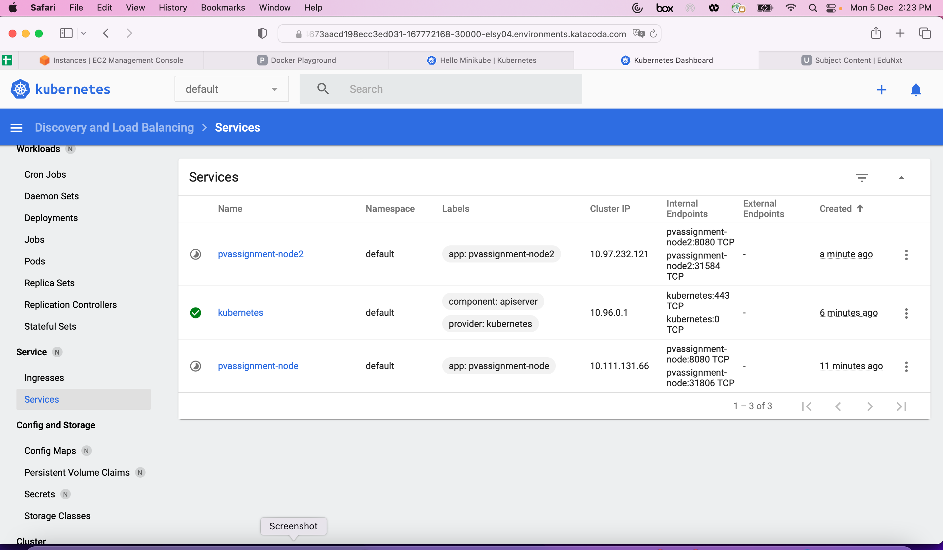

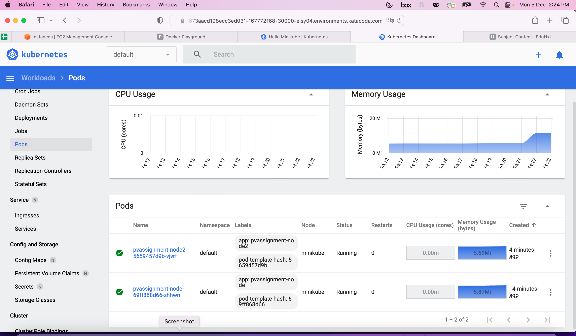

$ kubectl delete service pvassignment-node

service "pvassignment-node" deleted

$ kubectl delete deployment pvassignment-node

deployment.apps "pvassignment-node" deleted

$ kubectl delete service pvassignment-node2

service "pvassignment-node2" deleted

$ kubectl delete deployment pvassignment-node2

deployment.apps "pvassignment-node2" deleted

$ kubectl get services

NAME TYPE CLUSTER-IP EXTERNAL-IP PORT(S) AGE

kubernetes ClusterIP 10.96.0.1 <none> 443/TCP 8m48s

$

4. Create the poc on open shift architecture and its components and commands used on cluster

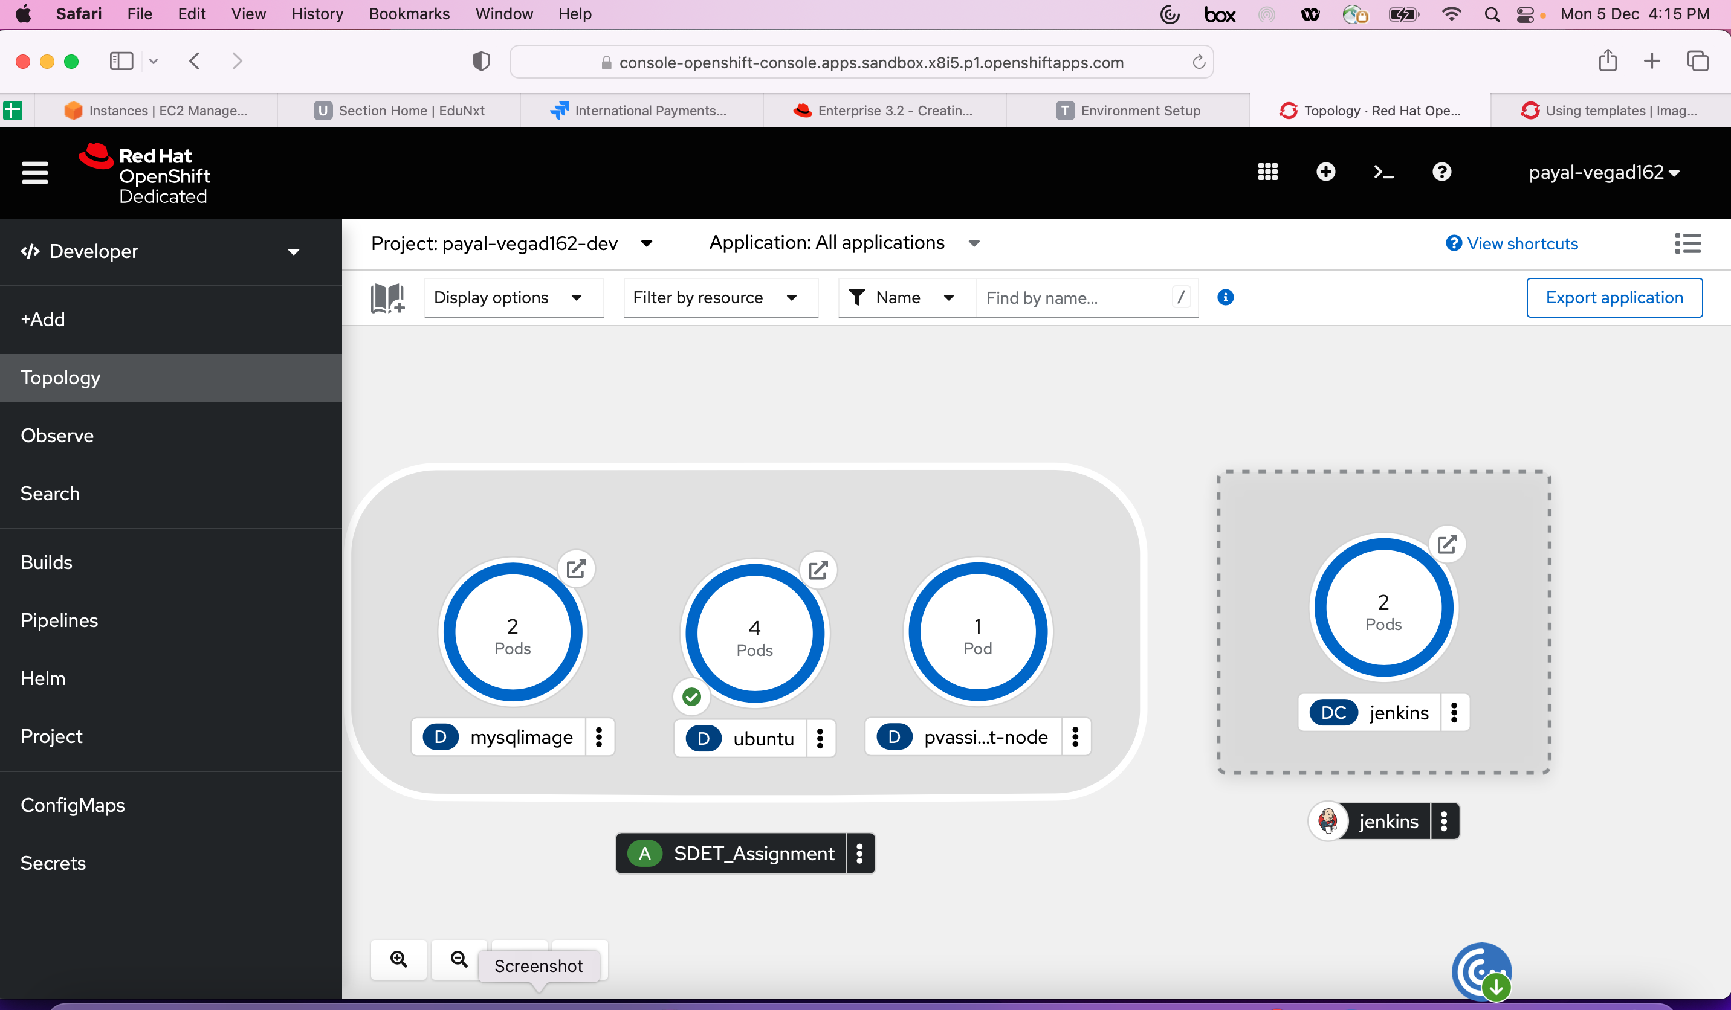

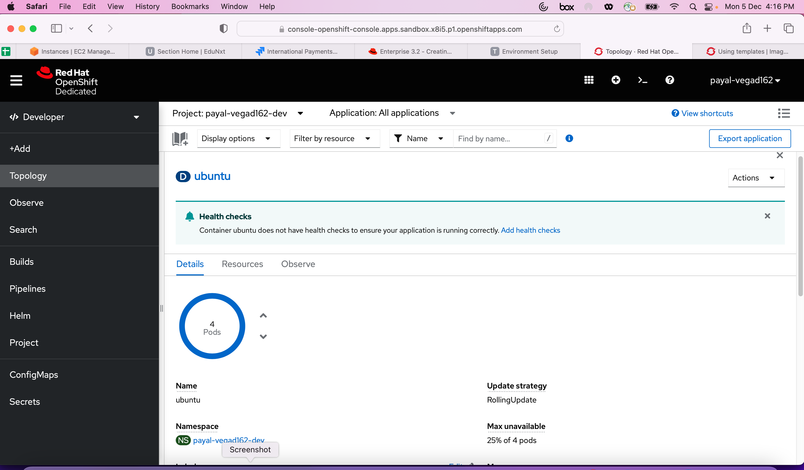

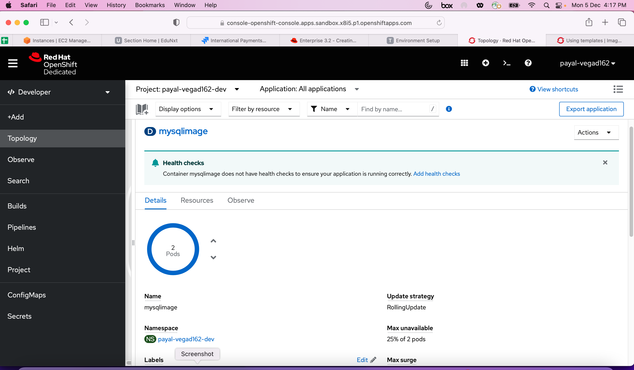

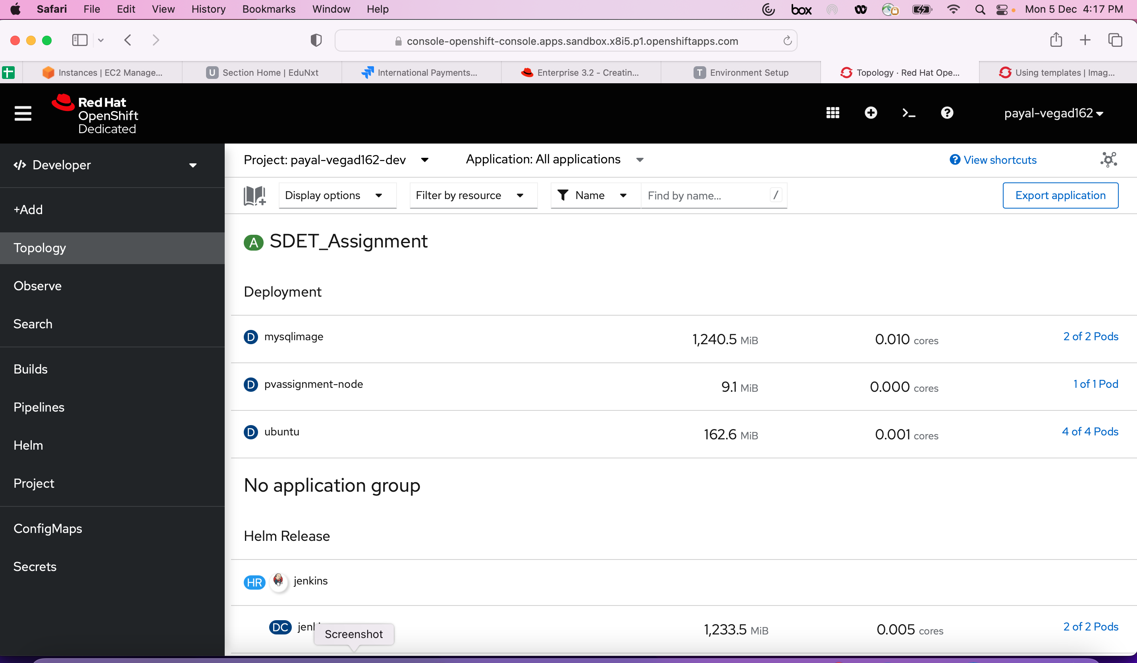

oc login --token=sha256~3HZsNnIv2kXSJk8t5OFW0cCx-YCWy1HM-NkJeWldQ38 --server=https://api.sandbox.x8i5.p1.openshiftapps.com:6443

Payals-MacBook-Air:~ payal.vegad@ibm.com$ oc login --token=sha256~3HZsNnIv2kXSJk8t5OFW0cCx-YCWy1HM-NkJeWldQ38 --server=https://api.sandbox.x8i5.p1.openshiftapps.com:6443

Logged into "https://api.sandbox.x8i5.p1.openshiftapps.com:6443" as "payal-vegad162" using the token provided.

You have one project on this server: "payal-vegad162-dev"

Using project "payal-vegad162-dev".

Payals-MacBook-Air:~ payal.vegad@ibm.com$ oc project

Using project "payal-vegad162-dev" on server "https://api.sandbox.x8i5.p1.openshiftapps.com:6443".

Payals-MacBook-Air:~ payal.vegad@ibm.com$ oc get pods -o wide

NAME READY STATUS RESTARTS AGE IP NODE NOMINATED NODE READINESS GATES

dotnet-sample-5-build 0/1 Completed 0 171m 10.129.3.247 ip-10-0-202-251.ec2.internal <none> <none>

dotnet-sample-6-build 0/1 Completed 0 163m 10.129.2.30 ip-10-0-202-251.ec2.internal <none> <none>

example-1-build 0/1 Completed 0 81m 10.129.3.66 ip-10-0-202-251.ec2.internal <none> <none>

jenkins-1-cx7xm 1/1 Running 0 90m 10.128.5.227 ip-10-0-240-107.ec2.internal <none> <none>

jenkins-1-deploy 0/1 Completed 0 121m 10.129.2.151 ip-10-0-202-251.ec2.internal <none> <none>

jenkins-1-rdxrt 1/1 Running 0 120m 10.129.2.164 ip-10-0-202-251.ec2.internal <none> <none>

mysqlimage-66f64bd5f8-xcnn7 1/1 Running 0 113m 10.128.5.225 ip-10-0-240-107.ec2.internal <none> <none>

mysqlimage-66f64bd5f8-z6rsm 1/1 Running 0 113m 10.129.2.181 ip-10-0-202-251.ec2.internal <none> <none>

pvassignment-node-5688599ccd-cfw9l 1/1 Running 0 79m 10.129.3.73 ip-10-0-202-251.ec2.internal <none> <none>

ubuntu-65bdb4474-cls7b 1/1 Running 0 83m 10.129.3.56 ip-10-0-202-251.ec2.internal <none> <none>

ubuntu-65bdb4474-dz2gc 1/1 Running 0 80m 10.131.2.232 ip-10-0-231-58.ec2.internal <none> <none>

ubuntu-65bdb4474-m7gqv 1/1 Running 0 80m 10.128.3.138 ip-10-0-248-164.ec2.internal <none> <none>

ubuntu-65bdb4474-w8kxl 1/1 Running 0 80m 10.129.5.94 ip-10-0-204-219.ec2.internal <none> <none>

Payals-MacBook-Air:~ payal.vegad@ibm.com$ oc status

In project payal-vegad162-dev on server https://api.sandbox.x8i5.p1.openshiftapps.com:6443

http://dotnet-sample-payal-vegad162-dev.apps.sandbox.x8i5.p1.openshiftapps.com to pod port 8080-tcp (svc/dotnet-sample)

svc/jenkins-jnlp - 172.30.119.206:50000

https://jenkins-payal-vegad162-dev.apps.sandbox.x8i5.p1.openshiftapps.com (redirects) (svc/jenkins)

dc/jenkins deploys openshift/jenkins:2

deployment #1 deployed 2 hours ago - 2 pods

https://mysqlimage-payal-vegad162-dev.apps.sandbox.x8i5.p1.openshiftapps.com (redirects) to pod port 8080-tcp (svc/mysqlimage)

deployment/mysqlimage deploys openshift/jenkins:latest

deployment #2 running for 2 hours - 2 pods

deployment #1 deployed 2 hours ago

svc/pvassignment-node - 172.30.203.253:8080

deployment/pvassignment-node deploys registry.k8s.io/e2e-test-images/agnhost:2.39

deployment #1 running for 2 hours - 1 pod

https://ubuntu-payal-vegad162-dev.apps.sandbox.x8i5.p1.openshiftapps.com (redirects) to pod port 8080-tcp (svc/ubuntu)

deployment/ubuntu deploys istag/dotnet-sample:latest <-

bc/dotnet-sample source builds https://github.com/redhat-developer/s2i-dotnetcore-ex#dotnet-6.0 on openshift/dotnet:6.0-ubi8

deployment #1 running for about an hour - 4 pods

svc/workspace297a85aeb1f54aff-service - 172.30.238.30:4444

deployment/workspace297a85aeb1f54aff deploys registry.redhat.io/web-terminal/web-terminal-tooling-rhel8@sha256:b76c2ea5ec2a70c4f9e0e5509b1857f112dece547bc0076feaa3b1782f769bbc,registry.redhat.io/web-terminal/web-terminal-exec-rhel8@sha256:eca0305ff85cdde8d6c2177831498166a7c981186cc0a53e3362bc3fa882cd4a

deployment #1 running for about an hour

bc/example source builds https://github.com/openshift/ruby-ex.git#master on openshift/ruby:2.7

build #1 succeeded about an hour ago - 01effef: Merge pull request #35 from pvalena/bundler (Honza Horak <hhorak@redhat.com>)

4 infos identified, use 'oc status --suggest' to see details.